Title: **SDA-final project**

Group members: **Syed Ahmed Shah, Zohaib Hassan**

**Soomro,**

RollNo#: **19SW44,19SW42**

Subject: **Software Design and Architecture**



**Problem Statement:**

A system is developed for the students in which new students have to register to use the system. But the registration process is carried out by console screen so the most of the new students get troubles with the registration process.

**Solution:**

A GUI screen should be incorporated into the system instead of console screen to provide new students with the ease of registration process.

**Introduction:**

A GUI screen is developed for registration of new students using java swing library with sufficient data including student’s name, roll number, email and phone number to be entered by the student.

The data is also validated by this screen by using appropriate validation process. Finally, the submitted data is stored on the access database with name ‘Students.accdb’.

**Class Diagram:**

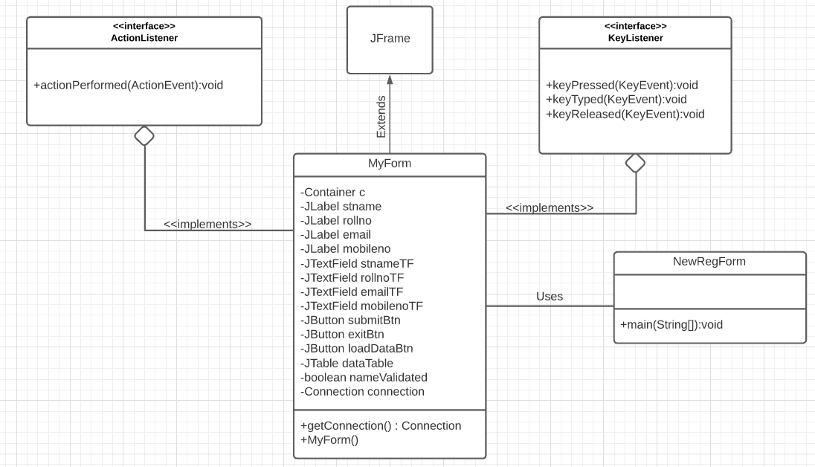

**Use Case Diagram:**

